Requirements for this paper:
 | Multi choice cards: |  | Programmable calculator: |  |  |  |  |  | Open book examination
 | Graphic paper: |  | Laptop:
EKSAMEN/  EXAMINATION: |  |  |  | Semestertoets 1b Semester test 1b | kwalifikasieprogram/  /QUALIFICATION program:
modulekode/  Module CODE: |  |  |  | EERI 423 |  |  |  |  | duur/  duration: |  | 1 uur / 1 hours
module beskrywing/ module description: |  |  |  | Telekommunikasie / Telecommunication |  |  |  |  | maks / max:
EKSAMINATOR(E)/  examiner(s): |  |  |  | Prof A.S.J. Helberg |  |  |  |  | datum /  date: |  | 2017-05-02
 |  |  |  |  |  |  |  |  | tyd / time: |  | 12:00
moderator: |  |  |  | Prof J.E.W. Holm

Totaal / TOTAL: 20

Beantwoord die volgende vrae in u antwoordskrif:
Answer the following questions in your answerbook:

- ‘n Superheterodene ontvanger het ‘n insetsein van 14.5MHz en die plaaslike ossilator is ingestem op 19MHz.
a) Wat is die Intermediere frekwensie? [1]
b) Wat is die beeld frekwensie? [1]
c) Dui die verskillende seine in die frekwensie domein aan. [2]
A superheterodyne receiver receives an input signal of 14.5MHz while the local oscillator is tuned to 19MHz.
a) What is the intermediate frequency? [1]
b) What is the image frequency? [1]
c) Show the different signals present in the frequency domain. [2]

a) IF = 19MHz-14.5MHz = 4.5MHz [1]
b) Image = 19MHz + 4.5MHz =23.5MHz [1]
c) 4.5MHz, 14.5MHz, 19MHz, 23.5MHz, amplitudes of IF and Image the same [2]

- ‘n Versterker met 6ohm impedansie moet aan ‘n antenna met 50ohm impedansie gekoppel word om teen 155MHz maksimum drywing te lewer. Ontwerp ‘n L tipe impedansie-aanpassingsnetwerk en gee die waardes van L, C en Q vir u netwerk. [6]
An amplifier with impedance of 6ohm must be connected to an antenna with a 50ohm impedance in such a way that the maximum power is delivered at 155MHz. Design an L-type impedance matching network and give the values of L, C and Q for your network. [6]

ANSWER
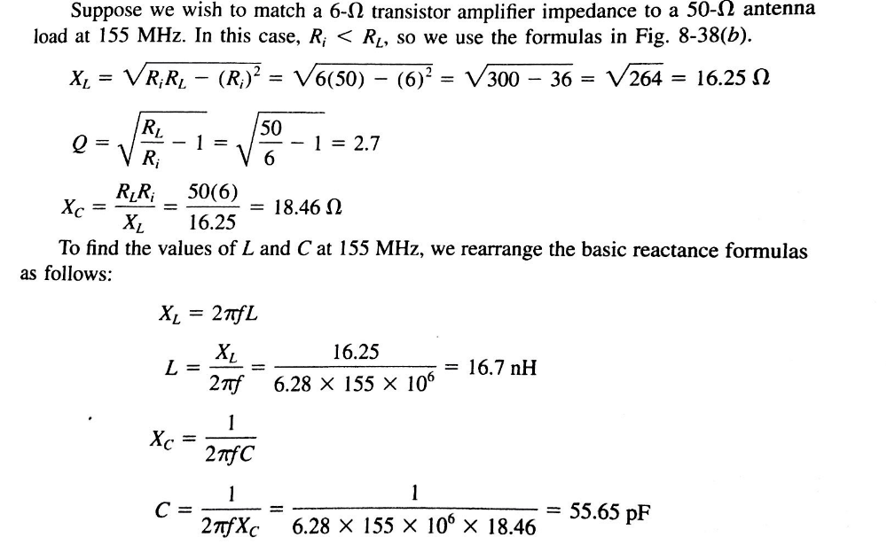

Regte groep formules kies = 1 punt, daarna een punt vir elke berekening Xc, XL, Q, L, C

- ‘n Ontvanger met ‘n 75ohm insetimpedansie werk teen ‘n temperatuur van 40 grade Celsius. ‘n 106MHz sein met ‘n bandwydte van 8MHz word ontvang. Die ontvangde seinsterkte van 6uV versterk deur ‘n versterker met ‘n ruis syfer van 3.1dB. Bepaal die volgende:
a) Die ruis drywing by die inset [2]
b) Die insetsein drywing [1]
c) Die inset sein-tot-ruis verhouding in dB [2]
d) Die uitset sein-tot-ruis verhouding in dB [3]
e) Die ruis temperatuur van die versterker [1]
f) Wat is die kleinste sein wat onderskei kan word? [1]
A receiver with a 75ohm input impedance operates at a temperature of 40 degrees Celsius. The received signal is at 106MHz with a bandwidth of 8 MHz. The received signal voltage of 6uV is applied to an amplifier with a noise figure of 3.1dB. Find the following:
a) input noise power [2]
b) input signal power [1]
c) input signal to noise ratio in dB [2]
d) output signal to noise ratio in dB [3]
e) noise temperature of the amplifier [1]
f) What is the smallest signal that can be discerned? [1]
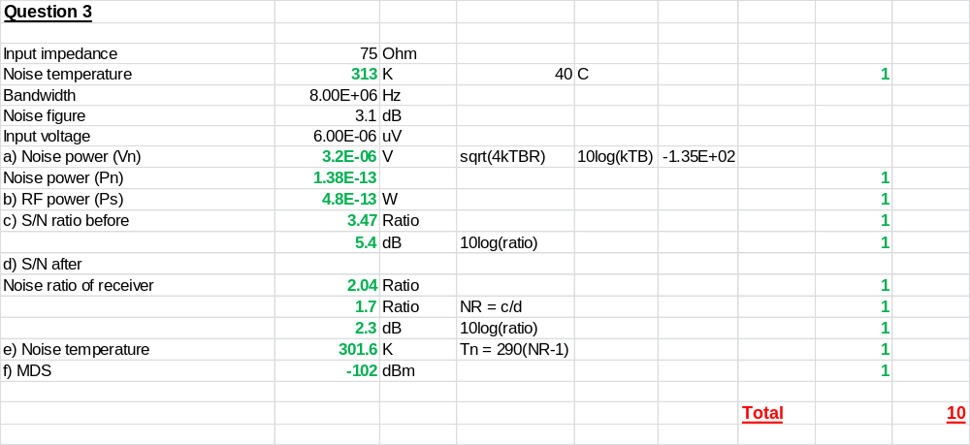

Formules EN TABELLE/ Formulas AND TABLES

Ontvangers, versenders en ruis / Receivers, transmitters, and noise

